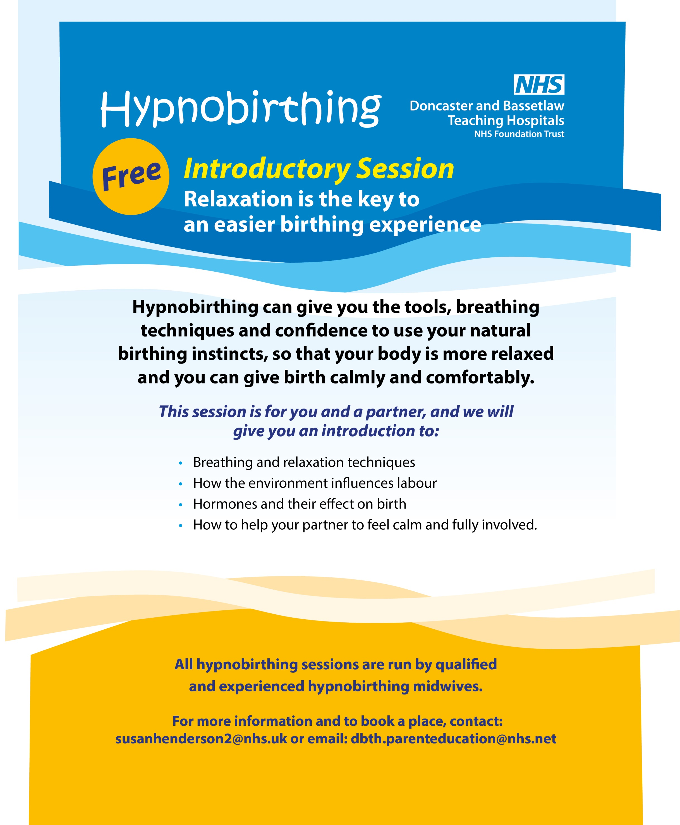

**Tuesday 28th August Tuesday 18th September Tuesday 25th September**

**Tuesday 16th October Tuesday 23rd October Tuesday 20th November**

**Tuesday 27th November Tuesday 18th December**

**6.00 - 8.00 pm - Bassetlaw Hospital**

**(A2 - Postnatal Ward)**