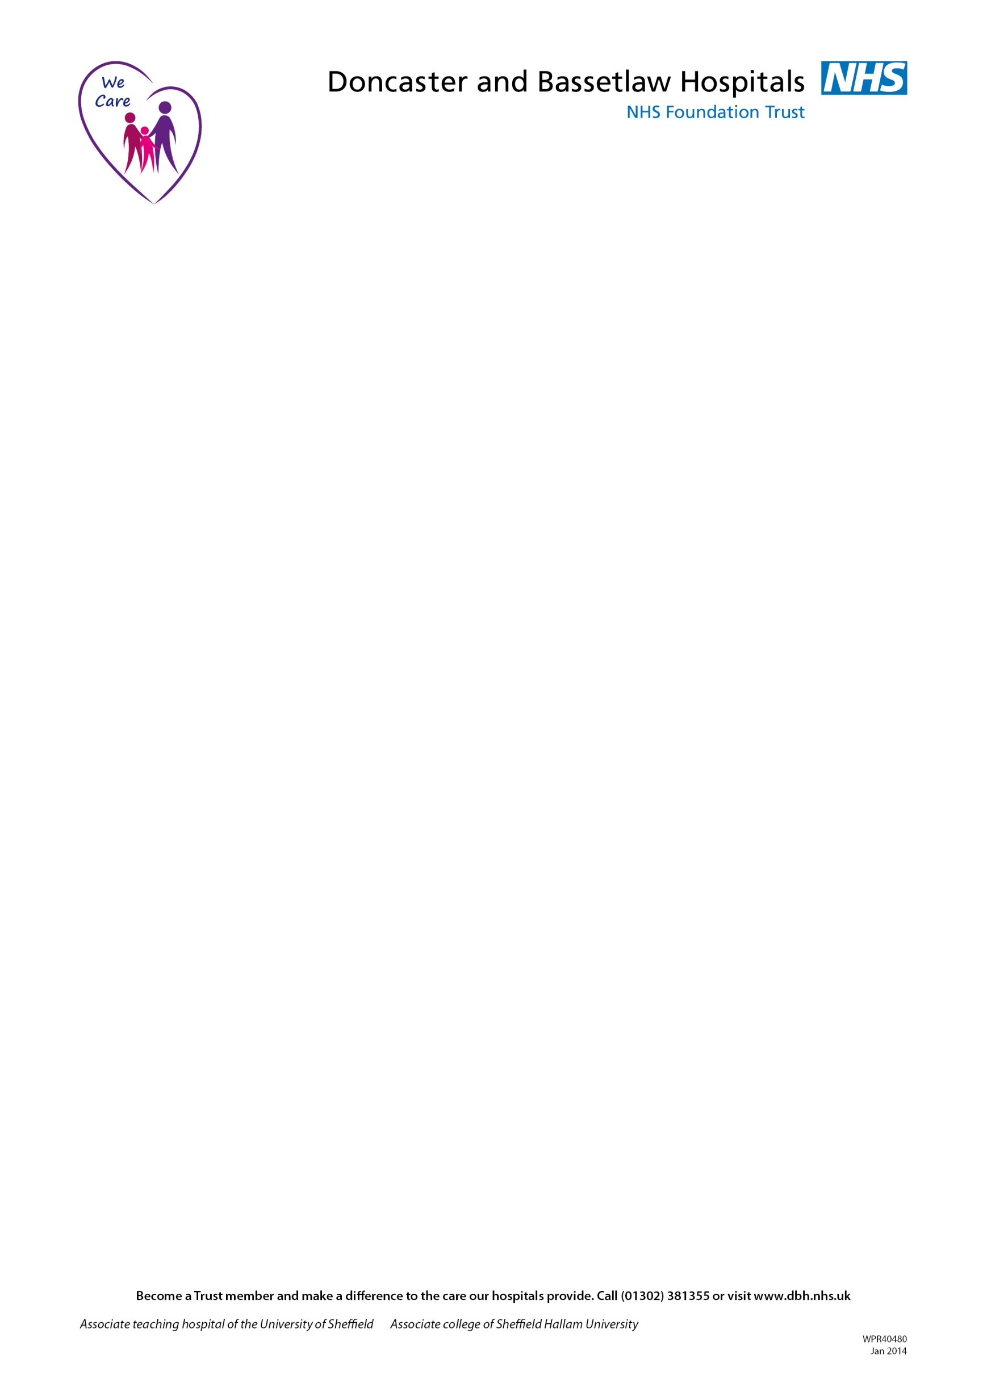
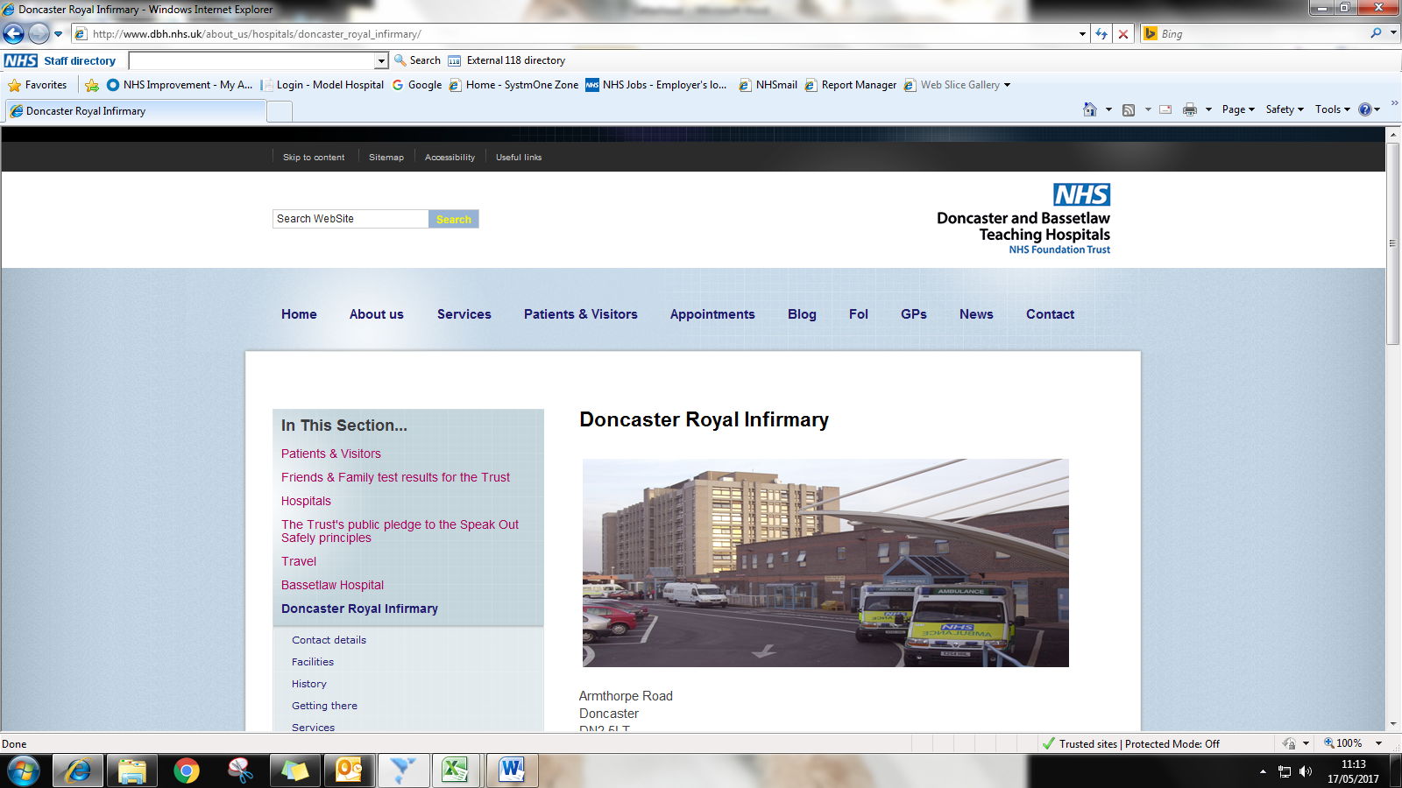

Request for the Involvement of The Children’s Speech & Language Therapy Service – Eating and Drinking

Child's First Name(s):………………………………………..… Surname: ………………………………
NHS Number:......................................................................... Sex: Male □ / Female □
Date of Birth: .………………………....................................… Age:………………………………………..
Address: ………………………………………………………………………………………………………
…………………………………………………….. Postcode: ………………………………
Named Carer(s):……………………………………………….. Telephone: ………………………………
Mobile: ………………………………
School/Nursery:.....…………………………………………….. Year Group: ………………………………
GP: …………………………………………………….. Practice: ………………………………
Home Language: .................................................................. Interpreter Required? Yes □ No □

Medical History:
Medical diagnosis (if known):..........…………………………………………………………………………….
Is the child generally delayed in other areas? (If so, is feeding in line with these skills?)……………….
Any medication taken…………………………………………………………………………………………….
Any significant health problems?: ………………………………………………………………………………
Any allergies or food intolerances?..........................................................................................................

Current Support Services:
Support Service | Contact Name
□ Paediatrician
□ Physiotherapist
□ Occupational Therapist
□ Educational Support
□ Health Visitor / School Nurse
□ Social Care
□ Family Support Worker
□ Dietician
□ Other
Reason for Referral:
………………………………………………………………………………………………………………………………………………………………………………………………………………………………………………
………………………………………………………………………………………………………………………
Feeding History:
At what age was the child first weaned? …………………………………………………………………… .
What types of food does the child eat now? (Including types of texture e.g chopped, lumpy or smooth)
……………………………………………………………………………………………………………………………………………………………………………………………………………………………………
What utensils are used? ………………………………………………………………………………………...
Does the child feed independently? (are they overloading the spoon or mouth?) ………………………………………………………………………………………………………………………
Have you observed the child feeding, if so what did you observe? ……………………………………………………………………....................................................................
Are there sensory patterns relating to the food that the child accepts or refuses? (e.g. colour / temperature)...............................................................................................................................................................................................................................................................................................................................................................................................................................................................................
Does the child show other sensory sensitivities? (e.g. doesn’t like loud noises, getting hands dirty?)………………………………………………………………………………………………………………………………………………………………………………………………………………………………………
Please tick if any of the following apply during/ after feeding:
Coughing during or after feeds |  |  | Restricted diet
Choking during or after feeds |  |  | Gagging on food
Poor weight gain |  |  | Difficulties managing secretions
Frequent chest infections  (more than 3 in a year) |  |  | Noisy or wet sounds during or after feeding
Vomiting following food/feeds |  |  | Change in breathing rate during feeds
Wheezing after feeding |  |  | Grimacing during feeds
Eyes watering, blinking, widening during feeds |  |  | Change in colour during feeds
Tires easily during feeds/meals

Previously Known to Speech & Language Therapy?
□ No
□ Yes, please state reason for re-referral: ..............................................................................................

Any Other Information You Feel Would Be Useful:
………………………………………………………………………………………………………………………………………………………………………………………………………………………………………………

Prior to sending this referral please consider these pre referral strategies which may be useful in resolving the current feeding issues.
- Is the spoon/fork overloaded?
- Has the child moved through different textures/stages too quickly, without consolidating skills? If so, give more practice at the earlier stage to allow for consolidation of skills. Also be wary of ready-made baby foods as these may contain harder lumps than home cooked food. Asking the family to complete a food diary maybe helpful.
- Does the child eat too quickly?
- Is the child awake and alert during feeding?
- Are mealtime routines established? If not, consider the child’s position and any distractions in the environment.
- Are the correct utensils being used for the age of the child?

Referrer Information:
Referral completed by: Name: ……………………………………………………..
Signature: ……………………………………………………..
Position: ……………………………………………………..
Base/ Address ……………………………………………………..
Telephone Number ……………………………………………………..
Date form completed: ……………………………………………………..

Parental Consent: I agree to my child being referred to the Speech and Language Therapy Service and understand that I may need to attend a clinic appointment.

Parent / carer name: ……………………………………………………..
Parent / carer signature: ……………………………………………………..
Please note we are unable to process referrals without a parent / carer signature

Please Note:

This referral is for an assessment of feeding skills only (biting, chewing and swallowing).

We are not able to assess those children who are experiencing behavioural feeding difficulties.

When you have completed this form please send it to:
Children’s Speech & Language Therapy Referrals, Child Development Centre, Doncaster Royal Infirmary, Armthorpe Road, Doncaster, DN2 5LT
Any incomplete forms will be returned to the referrer.

