

Paediatric Speech and Language Therapy Service

Student Placement Information Pack

Document written by: | Harriet Heffron – Therapy Manager, Children’s Speech and Language Therapy  Clare Attrill, Kate Wood & Jenna McKay (Paediatric Student Co-ordinators)
Date: | Autumn 2024
Version | 4.0
To be reviewed by: | Autumn 2025

Speech and Language Therapy Service

Student Placement Information Pack

Index

Welcome | 3
Philosophy and Aim of the Service | 4
The Children’s Team | 5
Overview of Doncaster Paediatric SALT Service | 8
Overview of Bassetlaw Paediatric SALT Service | 9
Essential Information | 10
Useful Telephone Numbers | 11
Food | 11
Recommended Reading | 12
Confidentiality Form | 15

STUDENT PLACEMENT INFORMATION PACK

WELCOME to the Speech and Language Therapy services of Doncaster and Bassetlaw Teaching Hospitals NHS Foundation Trust.

We look forward to working with you on your placement with us.

Please sign the attached confidentiality form and bring it with you on the first day of your placement.

You will have been provided with the name and contact details of your supervising clinician by the University placement coordinators. If you haven’t already, please contact your clinician for more in-depth information about your individual placement.

Enclosed is a brief introduction to our department that we hope you will find useful.

Best wishes

Clare Attrill, Jenna McKay & Kate Wood
01302 644633
dbth.saltpaedsstudents@nhs.net

Paediatric Student Placement Coordinators

SPEECH AND LANGUAGE THERAPY SERVICE

The Speech and Language Therapy Service is available for children and young people who live in the Doncaster and Bassetlaw area who have speech, language, voice, communication and feeding / swallowing problems.

The service is managed by Harriet Heffron - Therapy Manager, Children’s Speech and Language Therapy. The Therapy Manager is responsible for ensuring that:
- each individual patient receives a high standard of service
- each speech & language therapist maintain their specialist skills
- the speech & language therapy teams are well equipped and maintained

PHILOSOPHY OF SERVICE & OUR DBTH VALUES

To provide a courteous and considerate service to individuals with communication and feeding / swallowing difficulties and associated disorders.
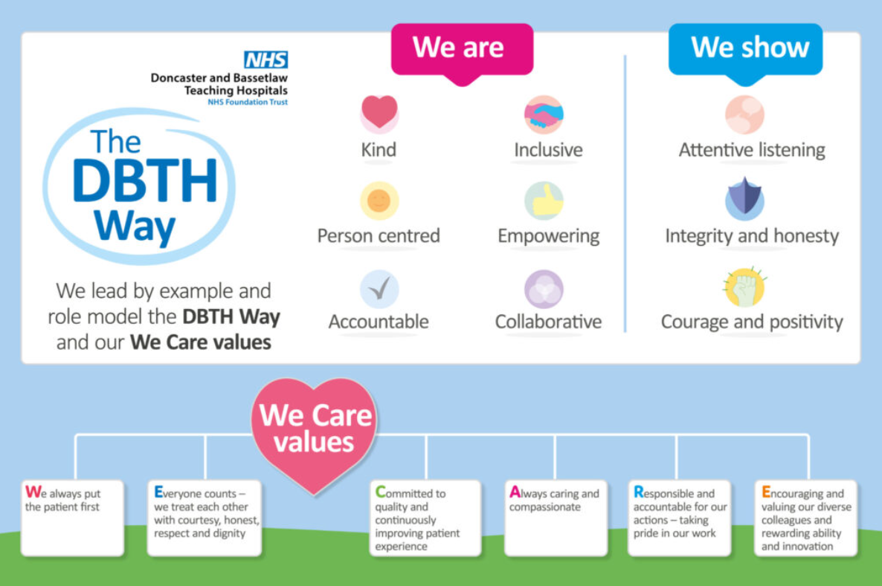

SERVICE AIMS

To provide a service that responds to individual needs of patients, carers and staff.

The service will be delivered with respect for the privacy, dignity, and the rights of the patient and their carers.

To work in close co-operation with health, education and social services professionals in the best interests of the patient.

The Speech and Language Therapy Service is part of the Clinical Specialities Division within the Trust and is one of the five professions that make up Clinical Therapy.

OUR CHILDREN’S TEAM

The Children’s Speech and Language Therapy Service supports children and young people in Doncaster and Bassetlaw aged 0-16 years who have difficulties with communication, or with eating, drinking and swallowing. We also support young people aged 16 – 19 years old who have an Education, Health and Care Plan (EHCP) who are attending schools in Doncaster and Bassetlaw. For certain clinical specialisms such as Stammering and Voice, some members of our team also see adults.

The Children’s Speech and Language Therapy Service provide assessment, diagnosis and treatment for children and young people with speech, language, communication, and feeding and swallowing difficulties.
See:
- Local Offer - Speech, Language and Communication - City of Doncaster Council
- Nottshelpyourself | Children's Speech and Language Therapy Service - Doncaster and Bassetlaw

The majority of difficulties fall into the following areas:
- understanding what is said to them
- expressing themselves
- talking clearly (saying speech sounds)
- stammering
- eating and drinking

The service sees children and young people in the following locations:

Outpatients

The Outpatients’ Clinic Team see children and young people from 2-18 years who have language, communication, stammering, voice and/or speech sound difficulties. They may be seen by a Speech and Language Therapist or by one of our Speech and Language Therapy Assistants.

Members of the Outpatient’s Team are based in various locations in Doncaster and Bassetlaw. They might be based at Devonshire House, Doncaster, Edlington, Mexborough, Thorne, Retford Hospital or Bassetlaw Hospital.

Child Development Centres (CDC)
There are two CDCs, one at Doncaster Royal Infirmary and the other at Bassetlaw Hospital; both offer Speech and Language Therapy services.

Special Schools
Services are provided to 5 of the special schools in Doncaster and the special school in Bassetlaw.

Mainstream Schools
Services are provided in mainstream schools are available under certain circumstances.
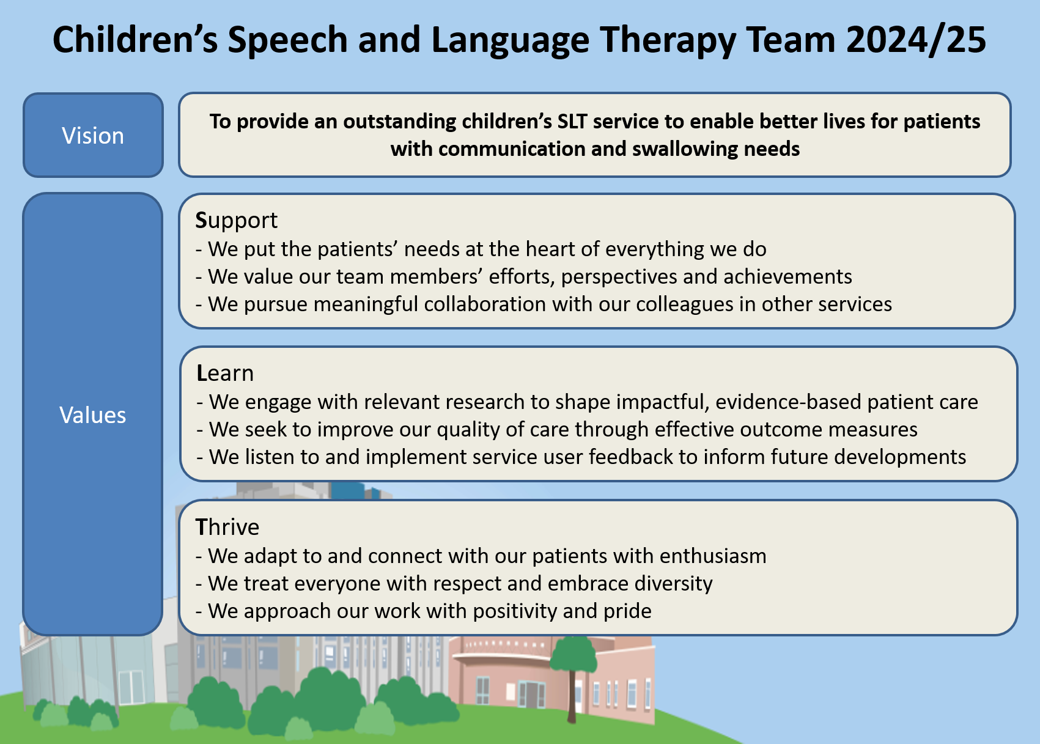

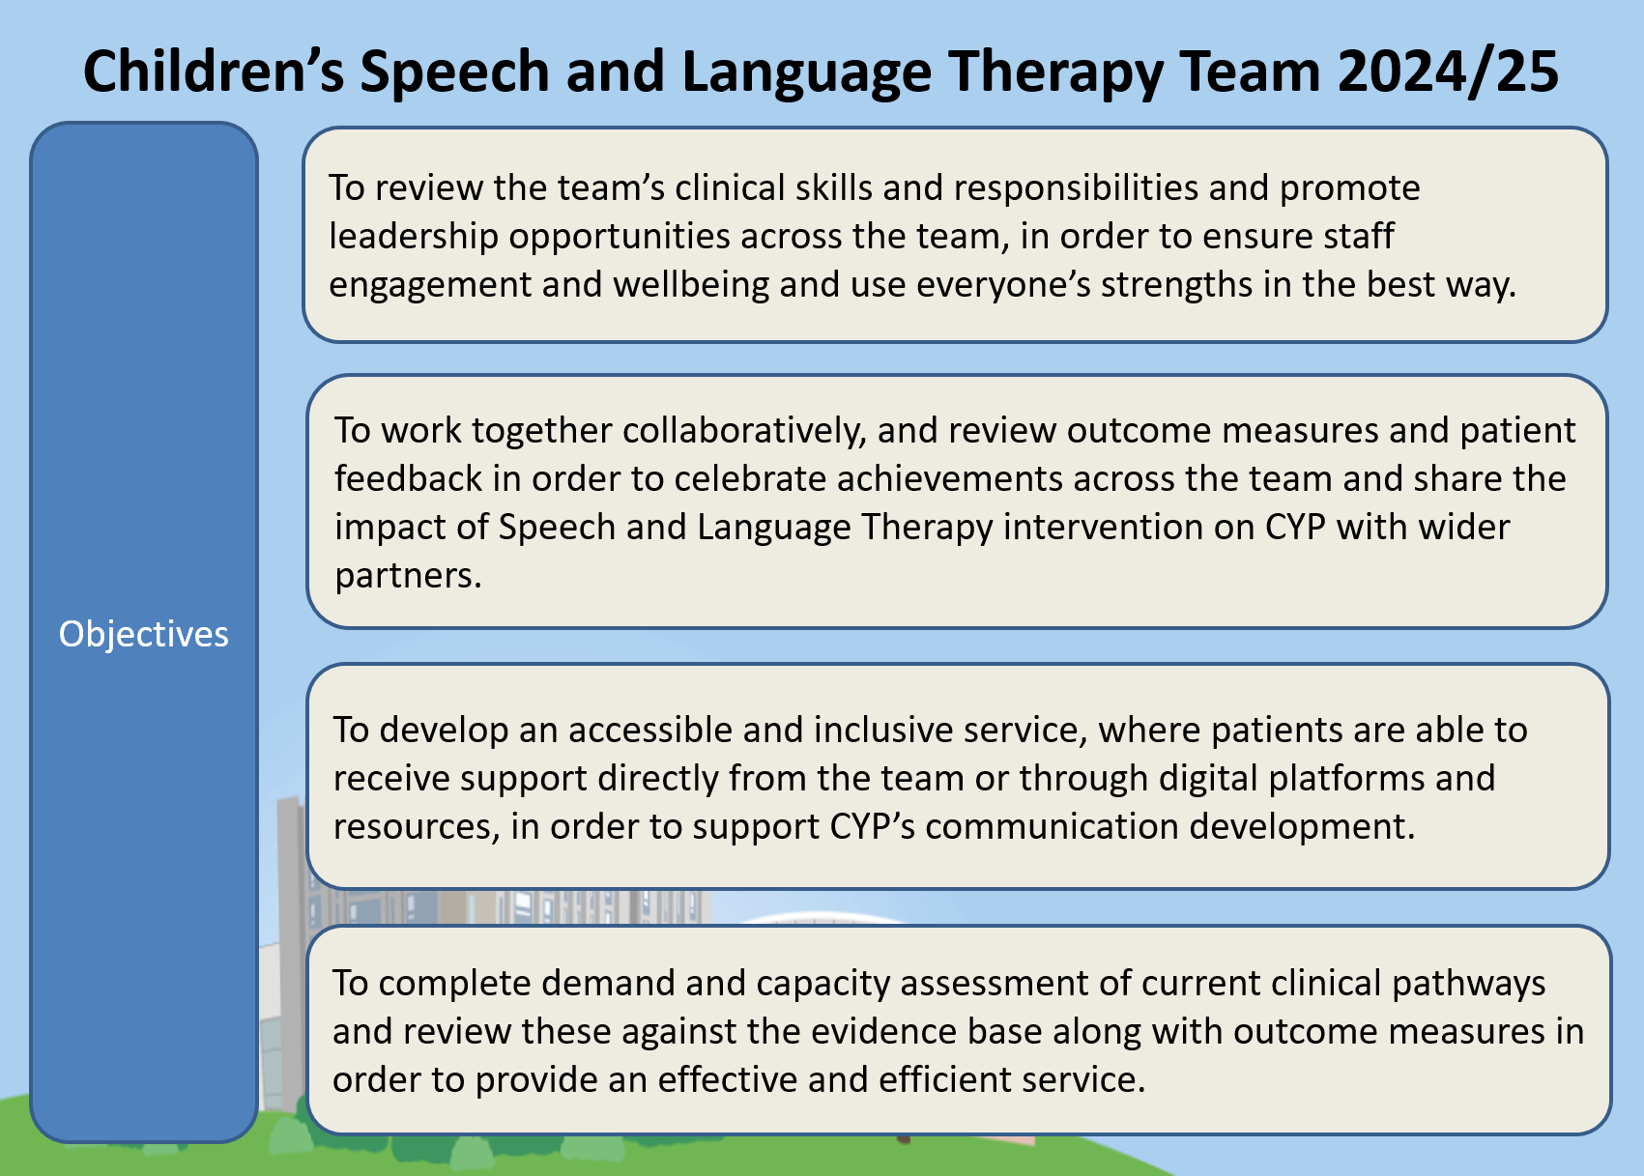

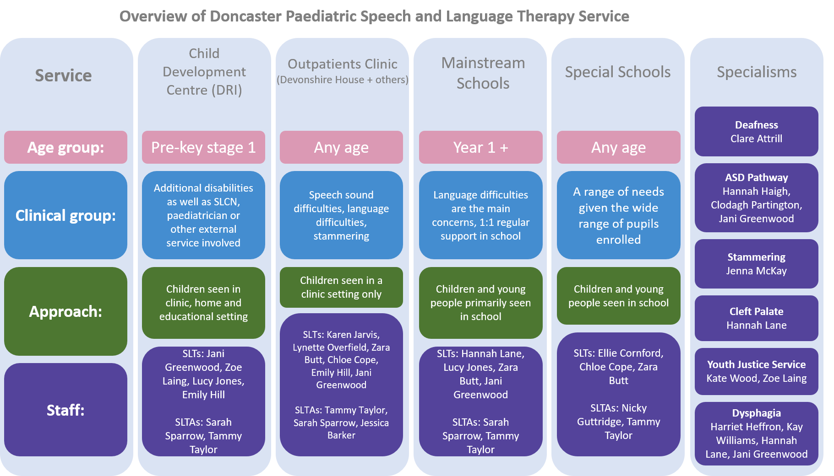

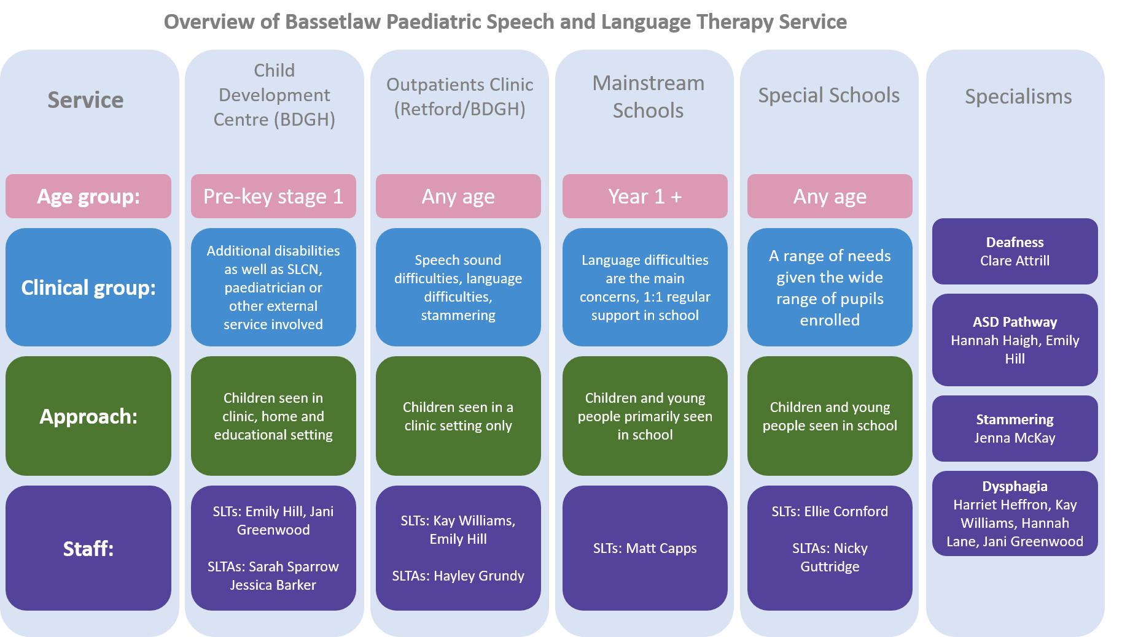

ESSENTIAL INFORMATION

Health & Safety – please refer to your student handbook
- FIRE – Please make sure that you are aware of the location of the fire exits, fire alarms and fire appliances within your placement location. You should know what the evacuation procedure is for the location where you are working and where the assembly point is situated.
- MOVING AND HANDLING – you will not be required to move any client or heavy piece of equipment. Please make sure you adhere to this rule for your own safety.
- IMMUNISATION – you are strongly advised to be immunised against TB, Polio, Tetanus and Hepatitis B.
- SMOKING – you are not permitted to smoke in the hospital grounds, clinics or school.
- INFECTION CONTROL – It is important to discuss infection control issues on the first day of your placement. In hospitals, you must be bare below the elbow with the exception of a plain wedding ring.
- APPEARANCE – For health and safety and infection control reasons, please keep long hair tied back and nails short, with no nail varnish or false nails. Jewellery should not be worn on placement with the exception of plain stud earrings, a plain wedding band is permitted. It is recognised that in today’s society many individuals have tattoos. Where a tattoo is in an area that remains exposed when wearing their uniform this must not be offensive. Please talk to your Practice Educator if unsure.

Professional Standards
- APPEARANCE/UNIFORM – please wear University provided Student SALT polo shirts for the duration of your placement. Please wear these with black trousers and flat black footwear.
- CONFIDENTIALITY – remember that everything you learn about a client is strictly confidential. You must not discuss your clients outside the clinical setting or with any person who is not involved in their management.
- PUNCTUALITY – Please arrive on time and keep to your planned timetable throughout the day.

Professional Responsibilities
- SICKNESS – if you are unable to attend due to sickness or for any other reason, please telephone your clinician and/or location as soon as you are able to.
- POLICIES AND PROCEDURES – please adhere to all local policies and procedures as outlined by your supervising therapist.
- DBS – please bring the original paperwork (no photocopies) to all placements

Safeguarding
- Your clinician will discuss local adult and children’s safeguarding procedures with you.

Emergency Procedures
- Please ensure that you are familiar with emergency procedures for the clinic you are attending.

Trust Induction
- A Trust Induction will be arranged for you prior to your first day of placement.
- Your practice educator will then carry out a local induction with you on your first day.

USEFUL TELEPHONE NUMBERS

Placement coordinators:

Clare Attrill 01302 644633 Email: clare.attrill@nhs.net
Jenna McKay 01302 644633 Email: jenna.mckay1@nhs.net
Kate Wood 01302 644633 Email: katherinewood2@nhs.net

Clinic / Hospitals:
Devonshire House 01302 644633
Retford Hospital 01777 200157
Child Development Centre, Doncaster Royal Infirmary 01302 642633
Bassetlaw Hospital 01302 644218

FOOD

In community clinics and school you will need to bring your own lunch.

Please contact your practice educator for more information relevant to your placement.

RECOMMENDED READING LIST

Please come prepared to your placement with knowledge of developmental norms for speech, language and communication. Please also see our referral form and checklists on the DBTH SLT website. The below reading lists are a guide only; your practice educator may specify which clinical area/s to focus your placement preparation.

Phonology
- Stackhouse and Wells
- Supporting and Understanding Speech Sound Disorder
- New Speech Sound Disorders Guidance - RCSLT
- Top Tips for Supporting Speech Sounds
- How to generalise sounds into everyday talking

Language
- Derbyshire Language Scheme (principles of)
- ‘Ages and Stages’ – Speech and Language UK
- Blank Questioning Information
- Meaningful Speech - Gestalt Language Development, Child-Led Therapy, and Neurodiversity-Affirming Practices.
- Podcast – ‘Two Sides of the Spectrum’ – Episode: Delayed Echolalia and Gestalt Language Processors –– Alexandria Zachos – Spotify/Apple Music

Developmental Language Disorder (DLD)
- CATALISE: A Multinational and Multidisciplinary Delphi Consensus Study. Identifying Language Impairments in Children; Bishop DVM, Snowling MJ, Thompson PA, Greenhalgh T, CATALISE consortium (2016) https://doi.org/10.1371/journal.pone.0158753
- Bishop, D.V.M., Snowling, M.J., Thompson, P.A., Greenhalgh, T. and (2017), Phase 2 of CATALISE: a multinational and multidisciplinary Delphi consensus study of problems with language development: Terminology. J Child Psychol Psychiatr, 58: 1068-1080. https://doi.org/10.1111/jcpp.12721

Some key papers on intervention effectiveness
- Law, J., Garrett, Z. and Nye, C. (2003). Speech and language therapy interventions for children with primary speech and language delay or disorder (PDF).
- Ebbels, S. (2013) Effectiveness of intervention for grammar in school-aged children with primary language impairments: a review of the evidence. Child Language and Teaching Therapy, 30 (1), 7-40.
- Ebbels, S., Wright, L., Brockbank, S., Godfrey, C., Harris, C., Leniston, H., Neary, K., Nicoll, H., Nicoll, L., Scott, J. and Maric, N. (2017) Effectiveness of 1:1 speech and language therapy for older children with (developmental) language disorder. International Journal of Language and Communication Disorders, 52 (4), 528-539.

Language/Language Disorder Books
- Language Disorders from Infancy Through Adolescence - Rhea Paul, Courtenay Norbury, and Carolyn Gosse
- Supporting Adolescents with Language Disorders - Edited by Sarah Spencer, University of Sheffield
- Introducing English Grammar by Kersti Börjars and Kate Burridge
- Introductory Linguistics for Speech and Language Therapy Practice by Jan McAllister and Jim Miller

Mainstream Schools
- Making Sense of Interventions for Children with Developmental Disorders: A Guide for Parents and Professionals - Caroline Bowen and Pamela Snow
- The Developmental Disorders Roadmap – Caroline Bowen, Pamela Snow, and Phillipa Brandon (forthcoming Spring 2025)
- https://www.rcslt.org/members/delivering-quality-services/send-reforms-guidance/#section-1
- RCSLT’s page on England’s SEND Reforms - https://www.rcslt.org/members/delivering-quality-services/send-reforms-guidance/ (requires login)

Autism
- ‘Amazing Things Happen’ Video
- National Autistic Society Website
- Autism Central Website
- Research the DSM-5 criteria for autism
- Uniquely Human: A different way of seeing autism, Barry Prizant (novel)
- The reason I jump, Naoki Higashida (novel that has been made into a documentary film)
- Resources relating to autism in girls:
- www.girlwiththecurlyhair.co.uk
- Autistic Girls network - White Paper: Autism, Girls & Keeping it All Inside
- The National Autistic Society’s online training module about autism and girls.
- The ‘Witherslack Group’ provide a range of webinars, articles, podcasts, and videos covering a range of topics which may be useful for parents/carers/professionals to access.

Augmentative and Alternative Communication (AAC)
- Communication Matters website What is AAC? - Communication Matters
- The Ace Centre Communication Partners (free); register to access the self-led online option at Communication Partners - Ace Centre (arlo.co)
- Smartbox (a powered AAC supplier) have a great online learning branch called Smartbox Academy Smartbox Academy (thinksmartbox.com); register for a free account, to access their free course called Introduction to AAC (FC01)
- Communication (autism.org.uk)

Youth Justice Service
- Supporting children and young people in the youth justice system
- Speech and language therapy in the justice system | RCSLT
- Sentence Trouble - Better Communication in the Youth Justice YouTube video
- A Day in the Life of a Speech and Language Therapists in the Youth Justice System YouTube video
- Speech and language therapy factsheets | RCSLT – Behaviour and communication; Children and young people who have experienced adversity and trauma; Developmental language disorder; Looked-after children; Supporting social emotional mental health

Stammering
- Browse www.stamma.org
- Medical Model and Social Model of Disability
- Demands and Capacities Model
- ‘I don’t need to be fixed’ YouTube video
Deafness
- Browse www.ndcs.org.uk for ways of communicating with and for deaf children, Listening Fatigue and background reading
- Best working practice with Teachers of the Deaf
- Ling Sounds: Using the Ling-Madell-Hewitt (LMH) Test Battery | ENT & Audiology News
- Deafness and speech and language therapy | RCSLT

CLP
- You can access online modules through the Leaders Project which covers the physiology of cleft, the impact on speech and assessment and intervention techniques - Cleft Palate Speech Therapy | LEADERSproject
- This paper is fantastic – Communication Disorders in Individuals with Cleft Lip and Palate: An Overview
- RCSLT guidance - https://www.rcslt.org/speech-and-language-therapy/clinical-information/cleft-lip/
- RCSLT factsheet - RCSLT_Cleft_Palate_A4_FINAL.pdf
- Cleft Lip & Palate Association

Dysphagia
- Dysphagia – Clinical information for SLTs | RCSLT / Dysphagia - guidance | RCSLT
- https://www.rcslt.org/wp-content/uploads/media/Project/RCSLT/rcslt-dysphagia-factsheet.pdf - RCSLT Factsheet on Dysphagia
- https://www.rcslt.org/wp-content/uploads/media/Project/RCSLT/rcslt-infant-dysphagia-factsheet.pdf - RCSLT Factsheet on Infant Dysphagia
- https://www.rcslt.org/members/clinical-guidance/eating-and-drinking-with-acknowledged-risks-risk-feeding/ - RCSLT Eating and Drinking with Acknowledged Risks
- Eating and Drinking Difficulties in Children: A Guide for Practitioners, April Winstock
- Working with Dysphagia - Working with Dysphagia – Lizzy Marks and Deidre Rainbow 2017
- Normal vs Abnormal swallow video
- https://iddsi.org/ - International Dysphagia Diet Standardisation Initiative
- IDDSI framework website
- Cervical auscultation
- Sensory differences Toomey & Associates (stgeorges.nhs.uk) / Support your child's sensory processing needs | Mid Yorks
- ARFID
- https://www.arfidawarenessuk.org/

Neonatal dysphagia
- Bliss website For babies born premature or sick | Bliss
- The role of a Speech and Language Therapist in neonatal care Introduction to Allied Health Professionals in Neonatal Care - elearning for healthcare

Doing Therapy
- Communication Trust “What Works?”
- How to: Formal Assessments – introductory video

CONFIDENTIALITY FORM

I the undersigned fully understand that sensitive information of any kind, coming into my possession whilst a student of the Doncaster and Bassetlaw Teaching Hospitals NHS Foundation Trust is strictly confidential.

I also understand that:

- Rights of access to this information are restricted and that I may only seek and obtain information if it is required to carry out the work for which I am employed.

- I must not divulge information I have obtained during the course of my employment in any shape or form to any other member of staff, to patients or the general public, except in the following circumstances:

- Anonymised case study conferences
- professional discussions required to carry out my duties, anonymised if necessary

In all cases, I will seek and be advised by my Line Manager, of those categories of the information, which I can divulge and to whom.

- I must refer to all other requests for information (including those from patients, relatives, the Police or press) to my Line Manager.

- I must comply with the rules regarding the safe storage, transportation and distribution of patient related information in accordance with the Data Protection Act.

Any departure from the strictest standards of confidentiality will be regarded as gross misconduct and may result in dismissal from employment/withdrawal of student placement.

Print Name:

Signed: Date:

Witnessed by: Designation:

Copy to be given to student and original to be kept on file

